

GoSupportNow User Manual

For PC Users

Version 4.2

RHUB Communications, Inc.
4340 Stevens Creek Blvd.
Suite 282
San Jose, CA 95129
support@rhubcom.com
http://www.rhubcom.com
Contents

Preface 4
Organization 4
Terminology 4
Constraints 5
GoSupportNow Control Panel and Key Functions for Presenter 5
1. Setting up GoSupportNow 6
2. Remote Support 8
2.1 Starting a Remote Support Meeting 8
2.2 Inviting the Attendee 8
2.3 Providing Multi-Party Support 9
2.4 Switching to Training Mode 9
2.5 Rebooting from Remote and Auto-Rejoining 9
2.6 Closing Remote Support Session and Locking Computer 10
2.7 Remote Support One To One File Transfer 11
3. Joining a Meeting 12
4. Common Features 14
4.1. Pausing and Starting Application Sharing 14
4.2. Changing Application Sharing 14
4.3. Show Specific Monitor in Multiple-Monitor Setup 14
4.4. Changing Presenter 15
4.5. Changing Controller 15
4.6. Chatting 15
4.7. Sending Files 16
4.8. Recording 18
4.9. Using WebCam 18
4.10. Using Whiteboard 19
4.11. Using Annotation 19
4.12. Floating toolbar 19
4.13. Hide the Attendee List 20
4.14. Disable Recording Function 20
4.15. Reporting 20
4.16. Changing Colors 20
4.17. Stop Additional Attendees 20
4.18. Remove Attendees 21
4.19. Change Language for GoSupportNow UI 21
4.20. Show all GoSupportNow Windows 21
4.21. Auto-Uninstall GoSupportNow from Attendee Computers 21
4.22. Show Presenter’s Desktop When Meeting Starts 22
4.23. Enable GoSupportNow Outlook toolbar 22
4.24. Remote Printing 22
4.25. Outlook Integration 23
4.26. Multiple Monitors for Presenter 24
4.27. Multiple Monitors for Supporter 25
4.28. Webcam Video 25
4.29. Polling 25
5. Unattended Support 28
6. Scheduling Meetings 33
6.1 Scheduling a Meeting 33
6.2 Editing a Scheduled Meeting 34
6.3 Starting a Schedule Meeting 34
6.4 Deleting a Schedule Meeting 34
7. Managing Profile 35
8. Support Contact 36

Preface
GoSupportNow is a collaborative remote support system. The client-server architecture requires Internet connectivity for its operation.

In GoSupportNow, a support session is called a meeting.

Organization
This manual provides the steps to use the GoSupportNow web collaboration system. The User Manual is organized as follows:

Section 1 | Setting up GoSupportNow
Section 2 | Remote Support
Section 3 | Joining a Meeting
Section 4 | Common Features
Section 5 | Unattended Support
Section 6 | Scheduling Meetings
Section 7 | Managing Profile
Section 8 | Support Contact

Terminology
The following terms are used throughout this manual. In a meeting, a participant can be either the Host or an Attendee:
- The Host (supporter) is the person who initiates the meeting. The Host must have a user account in GoSupportNow system.
- The Attendee (supportee) is the person invited by the Host to join a meeting. Attendee does not need an account in GoSupportNow system.

The Host or an attendee can either be:
- The presenter showing their computer to all participants
- A controller controlling the Presenter's keyboard and mouse

Constraints
Here are a couple of constraints:

- There is only one host and one presenter at any moment in a meeting.
- The host or the current presenter can assign any participant to be the presenter.
- The presenter can assign any participant or all participants to be a controller.

GoSupportNow Control Panel and Key Functions for Presenter
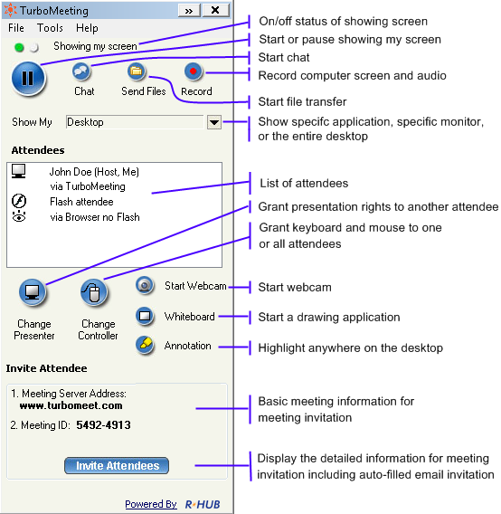

GoSupportNow Control Panel for Presenter

Setting up GoSupportNow
To host any type of meeting, you need to download and run the GoSupportNow client. You can do a manual or automatic download of GoSupportNow.

Manual download
- In a web browser, go to your meeting server web address:

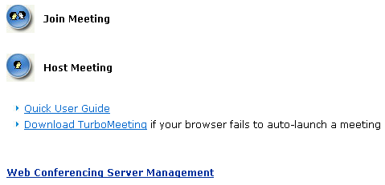

Home Page

- Click the Download GoSupportNow link.
- Download GoSupportNow and run it.

Automatic download
- In a web browser, go to your meeting server web address
- Click the Host Meeting icon.
- If a Java Virtual Machine (JVM) is installed in your system, a message will prompt for your permission to install GoSupportNow. Click Accept.
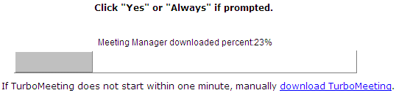
Automatic download
After GoSupportNow is installed, you can launch it by clicking the GoSupportNow shortcut on your desktop or via your computer’s Start menu → Programs → GoSupportNow → Start Meeting.

GoSupportNow shortcut

You will have to sign in to host a meeting. Provide the following information:
- Meeting Server Address
- Email Address
- Password
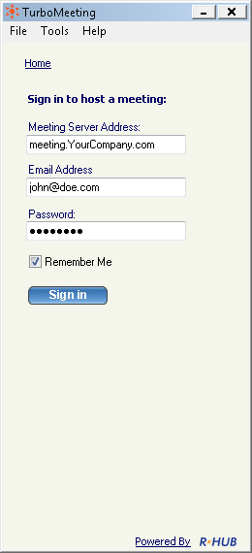
Signing in to host a meeting

Remote Support
This function simplifies the access to another computer so that you can control and support it. As the host, you can view and control the attendee’s computer as soon as the attendee joins the meeting. In addition, this feature provides a unique remote reboot capability.

2.1 Starting a Remote Support Meeting
- Launch GoSupportNow by clicking the GoSupportNow shortcut from the desktop
- Enter the login credentials and Sign In.
- In the meeting control pane the options displayed are:
  - Host an unscheduled meeting
  - Join a meeting
  - Schedule a meeting
Click Host an unscheduled meeting to host an impromptu support meeting.
- In the next step, choose the Remote Support meeting type.
- Enter the Password, which is optional. If you enter a password, the invitees also need to enter in the same password.
- Click Continue. This screen displays the Attendees, the Meeting Server Address, and the Meeting ID.

2.2 Inviting the Attendee
Consider a situation where you are facing a problem with your system and want the technician to access your system and solve the problem. In such situations the technician hosts a Remote Support Meeting and invites you to join the meeting.
Another instance could be a situation where more than one person is required to investigate and solve the problem. Consider for instance a case where you and your team leader have to support a computer facing some issue. In such a case, your team leader can initiate a Remote Support Meeting and invite you to support the system facing problems.
By clicking Invite Attendees the meeting details can be emailed.
 The option to Join a view-only meeting is not available for Remote Support.

2.3 Providing Multi-Party Support
To join a meeting as a joint-supporter, you need a user account in the GoSupportNow system and follow the steps below.
- Follow the path Start menu → Programs → GoSupportNow → Start Meeting or double-click the GoSupportNow shortcut from the desktop.
- Enter the login credentials and Sign In.
- In the meeting control pane the options displayed are:
  - Host an unscheduled meeting
  - Join a meeting
  - Schedule a meeting
Click Join a meeting to join a Remote Support meeting started by someone else.

- There are two different ways in which you can join the meeting.

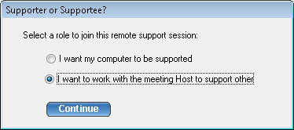

Options to join Remote Support Meeting

Here you choose the option I want to work with the Meeting Host to support other.

2.4 Switching to Training Mode
During a support session, you as the host may want to show your screen to the attendee to conduct a training session. You can Change Presenter so that you are the presenter. After the training session, you can change the presenter back to the attendee again.

2.5 Rebooting from Remote and Auto-Rejoining
There are situations where the attendee is not available at the system throughout the support session. However, the host may have to reboot the attendee’s computer during the support session.

To reboot the attendee computer, the host simply clicks the Reboot button and chooses the reboot mode: “Reboot” or “Reboot to Safe Mode”.

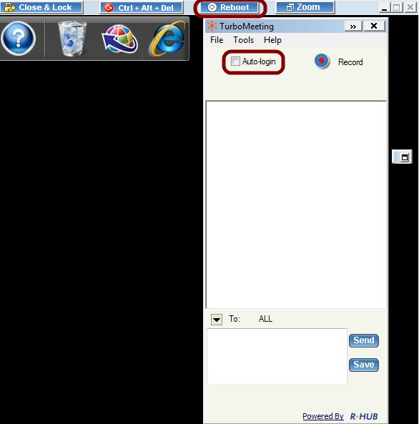

The view window of the remote support host

You can ask the attendee to input his computer password so that after reboot the remote computer can auto-login. This is important for unattended support. Follow the steps below:
- Click the Auto-Login on the meeting panel.
- Input the password of the computer.

2.6 Closing Remote Support Session and Locking Computer
There are situations where the attendee is not available at the system throughout the support session. If the host finishes work on the remote computer, the host can click the Close & Lock button. This will close the remote support session and, as a safety measure, lock the attendee’s computer. The result is that the attendee’s computer will display the Windows Login screen if their computer is running Windows.

2.7 Remote Support One To One File Transfer
During a support session, you as the host may want to transfer files from your computer to the attendee’s computer, or vice versa. To transfer files, the host clicks the Send Files button in GoSupportNow. The host then chooses which files and folders to transfer and which direction to transfer the files. For security reasons, a warning message is displayed if the host tries to transfer a file from the attendee’s computer.

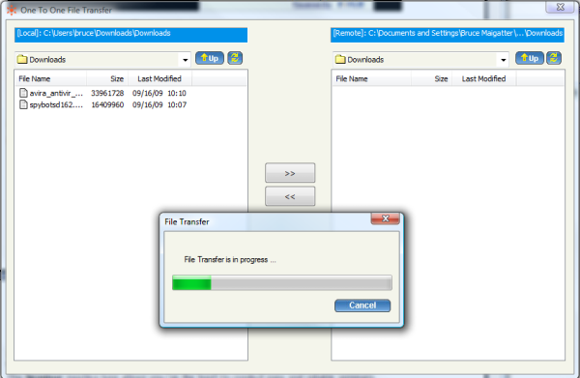
File Transfer window during Remote Support session

Joining a Meeting
When you receive an invite from the host, open your browser and
- Go to the meeting server’s address
- Click the Join Meeting icon.
- Fill in the Meeting ID, Meeting Password and Your Name.
- Click the Join Meeting button.

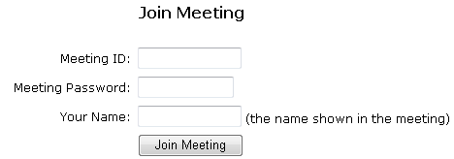

Joining a meeting

- If the meeting is a seminar, which does not require any download, you now join the meeting.
- If the meeting is not a seminar and you have a Java Virtual Machine (JVM) installed in your system, a message will prompt for you to install GoSupportNow. Click Accept. Otherwise, you have to download the GoSupportNow client and run it.

If you have already installed the GoSupportNow client, follow these steps to join a meeting:
- Launch GoSupportNow by clicking the GoSupportNow shortcut from the desktop.
- Click the Join a Meeting button.

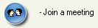
Option to join a meeting

- Enter the Meeting Server Address, Meeting ID, Meeting Password (if required), and Your Name.
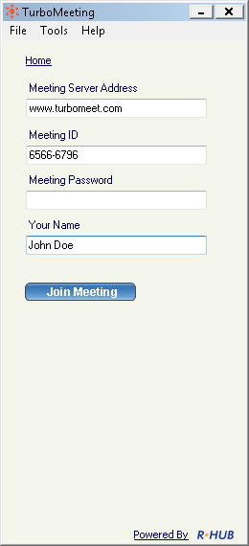
Details required while joining a meeting

- Click Join Meeting.

Common Features
There are many features that are common to all four types of meetings. This section discusses the common features.

Pausing and Starting Application Sharing
When you start a meeting, by default, your desktop will be shown to meeting attendees. The green icon indicates that your screen is being shown.

Icon indicating active application sharing

To pause showing your screen, click the Pause button. The red icon indicates that the meeting is being paused.

Icon indicating that application sharing is paused

To start showing your screen, click the Start button. The icon will now become green.

Changing Application Sharing
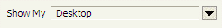
By default, your desktop is shown to the other attendees. The Show My drop-down list displays all the applications open in your system. To show another application, click the Show My drop- down and choose a running application from the list.

Option to change application sharing

Show Specific Monitor in Multiple-Monitor Setup
The presenter can optionally choose to show a specific monitor in a multiple-monitor setup. The Show My drop-down list shows each monitor as a separate viewable choice.
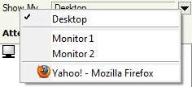
Option to show single monitor in multiple-monitor setup

Changing Presenter
The attendees who have joined the interactive meeting can also be the presenter to show his or her computer screen to meeting participants. By default, the host will be the presenter. However, during a meeting the host and the current presenter can assign any participant to be the presenter. To change the presenter, click Change Presenter and choose the presenter.

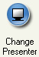
Option to change presenter

Changing Controller
During the meeting, you as the presenter can assign a participant as the controller. A controller is the person who can control your mouse and keyboard.
To change the controller, click Change Controller. You can assign control directly to a specified participant or to all.
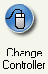
Change Controller option
Click Change Controller then Reclaim Controller to reclaim control from the specified controller(s).

Chatting
While convening a meeting you can also chat with attendees. To chat with the attendees:
- Click Chat.
Chat button

- In the Chat window you have the option of choosing the attendees with whom you want to chat. Clicking the drop-down arrow lets you choose specific attendees to chat with.

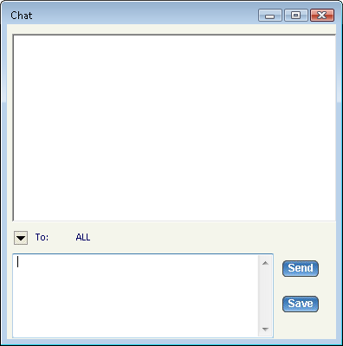
Chat window
- Type in the text and click Send. To save the chat transcript click Save. Browse to the location and save the file. The chat is saved as a text file or a rich text file.

Sending Files
During a meeting, there may be a need to send some files between meeting participants. Instead of opening a mailing client and sending files, a participant can send files using GoSupportNow. To send files:
- Click Send Files to open the File Transfer dialog box.

Send Files button
- Click Add Files/Folders.

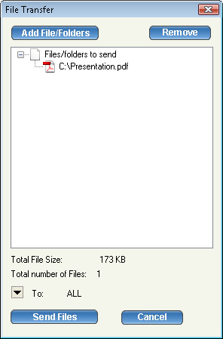

File Transfer dialog

- Select a particular folder from the drop-down list. All the folders and files in that directory are displayed.
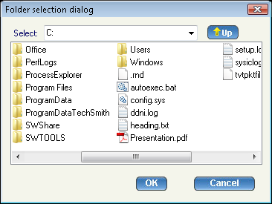
Folder selection dialog
- Select the files, folders, or both and click OK. They are added to the list of files/folders to be sent.
- In the File Transfer dialog, click the drop down-arrow next to the To label, and then select the participants to whom the files should be sent. By default, the files are sent to all other participants.
- Click Send Files.

Recording
During a meeting, you can record the actions on the presenter’s screen. It also records the voice captured by the microphone on the presenter’s computer. To record meeting conversation, you need to turn on your speaker phone and move it close to the microphone on the presenter’s computer in order to capture conversations.
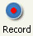
Click the record button to start recording and click it again to stop recording. When stopping the recording, the system prompts to ask you where to save the recording file. The file is an executable. Just run the file and it will replay the entire recording session.

Using WebCam
During a meeting, each presenter can start their own web camera, or WebCam. The presenter’s WebCam video will be visible to all attendees. If the presenter is changed, the new presenter can start their own WebCam, although only the current presenter’s WebCam is visible to attendees.
WebCam option
If the web camera is not visible to attendees, the presenter can try to turn off or slow down hardware acceleration for the graphics card. On Windows, this setting is available via Display Settings, then by clicking the Advanced settings button, then by clicking the Troubleshoot tab.
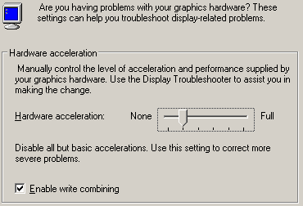
Windows graphics card Hardware acceleration setting

Using Whiteboard
While making the presentation you might have to illustrate some points. The Whiteboard option in GoSupportNow is used for this purpose. Click Whiteboard and the Paint application opens, where you can illustrate certain points or draw diagrams.
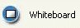

Whiteboard option

Using Annotation
Using the Annotation feature you can highlight topics in your presentation. Click the Annotation button and choose the type of annotation from Pen, Highlighter, Spot and Arrow. Then, emphasize the interesting area using the mouse pointer.
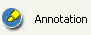
Annotation option
When the annotation option is active, normal keyboard and mouse input ceases and essentially your computer screen freezes. To unfreeze your computer screen, hit the “Esc” key or click the Annotation button and select “Stop Annotation”.

Emphasis using Annotation feature

You can change the size of the annotation pen. Click the “Tools” menu item then “Annotation Pen Size” and select a new size.

Floating toolbar
The floating toolbar has the advantage of using very little of the presenter’s screen space during a presentation while still providing buttons for the most common features of GoSupportNow.
Floating toolbar

Hide the Attendee List
As the meeting host, you can hide the attendee list from your attendees. Click the “Tools” menu item and then uncheck “Attendees can view attendee list”.

Disable Recording Function
As the meeting host, you can disable recording functions so that none of the attendees can record the meeting session. Click the “Tools” menu item and then uncheck “Attendees can record”.

Reporting
The reporting feature is covered in the Administrator Manual.

Changing Colors
There are three color options available in GoSupportNow that let you choose between speed and image precision:
- Low Quality (fastest)
- High Quality
- Truecolor (24-bit slowest)
To change the color, choose the menu item “Tools” then “Change Color” and choose the relevant option. The High Quality color setting is recommended for its combination of speed and image quality.

Stop Additional Attendees
As the meeting presenter, you can stop any further attendees from joining the meeting. Click the “Tools” menu item then “Options” and check “Stop additional attendees”.

Remove Attendees
As the meeting presenter, you can remove attendees from the meeting. In the Attendees list, right click the attendee’s name and choose “Remove this attendee”.
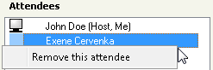

Change Language for GoSupportNow UI
Each GoSupportNow user can change the language of their GoSupportNow user interface. Click the “Tools” menu item then “Options” and select a language from the drop-down list.

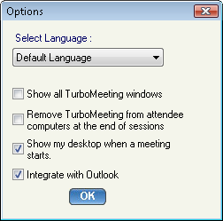

Options dialog

Show all GoSupportNow Windows
As the meeting presenter, you can display all transparent windows on your screen. By default, attendees cannot see the host’s GoSupportNow and its associated windows since these windows are treated as transparent. To expose the GoSupportNow control panel and associated windows, click the “Tools” menu item then “Options” and check “Show all GoSupportNow windows”.

Auto-Uninstall GoSupportNow from Attendee Computers
As the meeting host, you can tell the system to automatically uninstall the GoSupportNow client on the attendee computers at the end of a meeting session. Click the “Tools” menu item then “Options” and check “Remove GoSupportNow from attendee computers at the end of sessions”.

Show Presenter’s Desktop When Meeting Starts
As the meeting presenter, you can display all transparent windows on your screen when a meeting starts. Click the “Tools” menu item then “Options” and check “Show my desktop when a meeting starts”.

Enable GoSupportNow Outlook toolbar
Users can add a GoSupportNow toolbar to Microsoft Outlook. Click the “Tools” menu item then “Options” and check “Integrate with Outlook”. The Outlook toolbar looks like this:
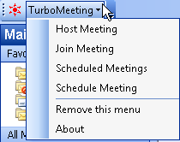
GoSupportNow Outlook toolbar

Remote Printing
Remote printing is the ability to print directly from the host computer to a printer on the attendee’s network. This is useful if the host is printing from an application that is not installed on the attendee’s computer. To print to an attendee’s printer, open the file to print and select Print. Choose the GoSupportNow Printer and click OK.
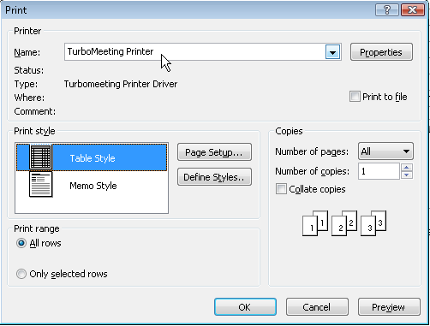
Choose GoSupportNow Printer to send output to attendee’s printer

Outlook Integration
Outlook messages with calendar events are automatically generated when a GoSupportNow user schedules a meeting. An Outlook message can also be automatically generated when a user chooses to invites attendees to a future or an active meeting.
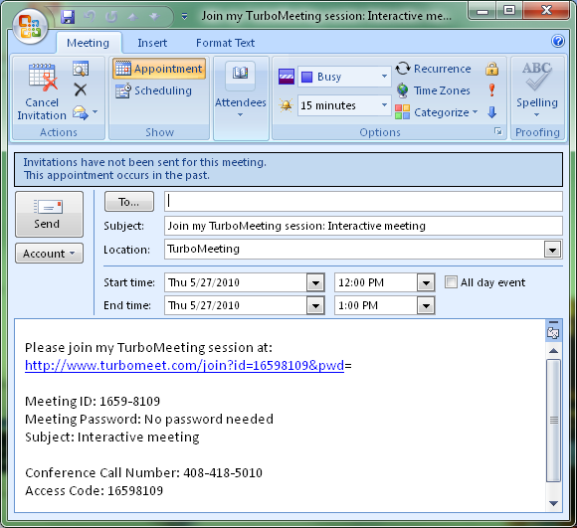
Outlook message with calendar information is automatically generated for a scheduled meeting

Multiple Monitors for Presenter
If a meeting presenter has multiple monitors, the presenter can choose to display a specific monitor or the entire desktop, which is composed of more than one monitor.

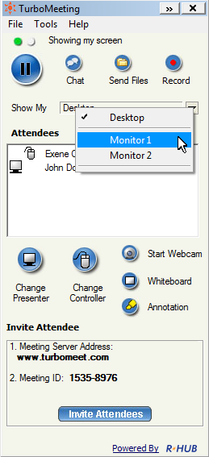
Multiple Monitor selection in GoSupportNow
Below is the view that attendees would see for a presenter that has multiple monitors when the entire Desktop is displayed:
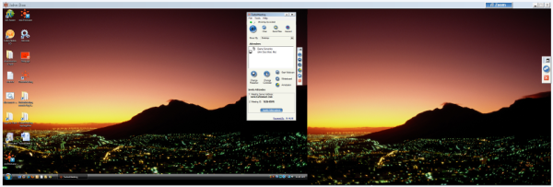
Multiple Monitor view if entire Desktop shown

Multiple Monitors for Supporter
A person that is providing Remote Support to a computer with multiple monitors is given the option in GoSupportNow to show the entire Desktop or to show individual monitors as shown below:
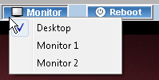
Remote supporter can view entire Desktop or individual monitors

Webcam Video
During a meeting, the host can display the video from their webcams by clicking the “Start Webcam” button.
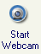

Polling
The host of a meeting can create a poll with questions and multiple choice answers for the attendees. Poll questions can be created ahead of time by clicking the Poll link in the user’s “List of scheduled meetings”. Or the host can create a poll question during the meeting by clicking the “Tools” menu item then the “Poll” option.

Each poll question can have up to five pre-determined answers. The poll can limit the attendees to voting for just one response or allow the attendees to vote for multiple responses.
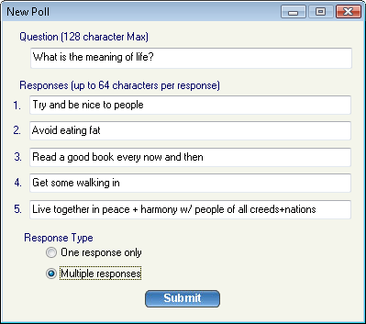
Interface for creating a new Poll
After the poll question is created, the host can begin polling the GoSupportNow attendees for responses. The attendees will see a window similar to this:

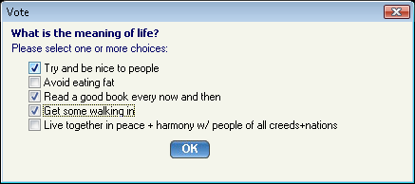
Attendees voting window
The poll stays open until the host decides to close polling. Once the poll is closed, the results are tabulated for each answer. The poll is blind: there is no way to determine how each attendee voted.
The host’s “Manage Poll” window provides a Close Polling link. (A Start Polling link initially appears where Close Polling appears below).
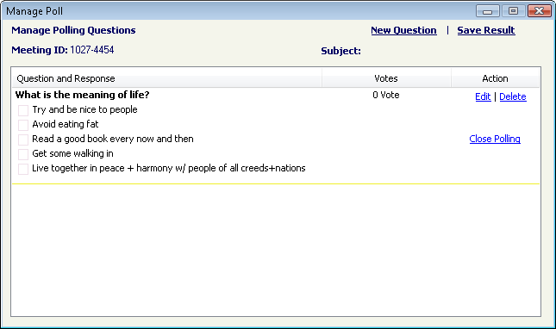
The host’s “Manage Poll” Interface

After the host closes the polling, the host sees a Share link where the Close Polling link used to be. When the host clicks the Share link, the attendees see a window with the polling results. Finally, the host can click the Share link to close each attendee’s “Polling result” window.
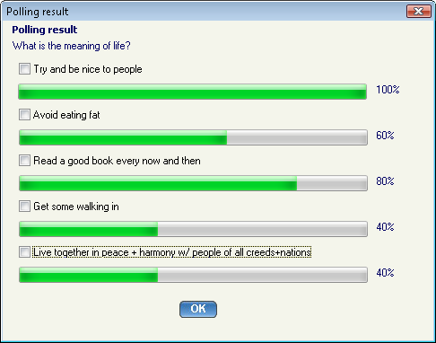
The attendee’s “Polling result” window

Unattended Support
Unattended Support is a support session that occurs when the person being supported, the supportee, is not present when their computer is receiving support.

To enable an Unattended Support session (or meeting), the supporter first starts a Remote Support meeting and clicks continue:

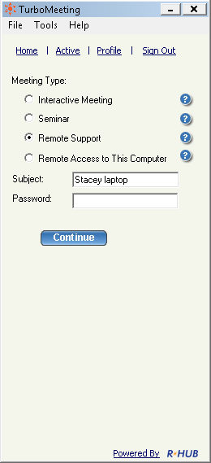
Supporter starts a Remote Support meeting

On the supportee’s system, the supportee installs GoSupportNow and joins this Remote Support meeting with the generated Meeting ID.

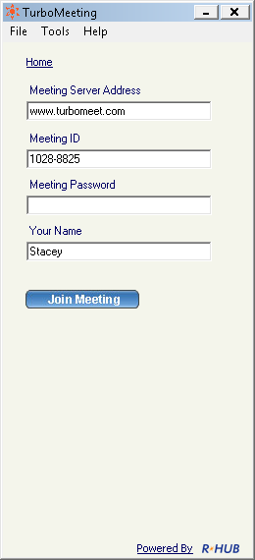
Supportee joins the Remote Support meeting

The supportee should accept the default answer: “Control and view your computer”:

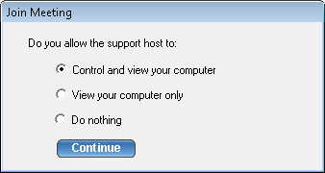
Supportee allows supporter to Control and view your computer

If the supportee is not a Windows Administrator, the “Run as Admin” option appears. Click the “Run as Admin” icon and specify an Admin’s Name and Password for the supportee’s computer:

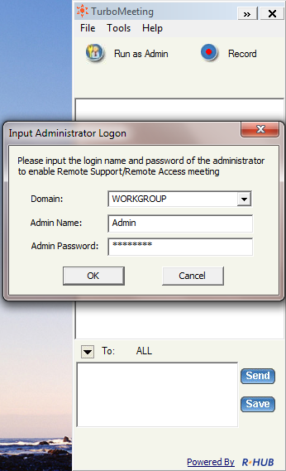
For Windows non-Admin users, specify an admin name and password
On the supporter’s computer, choose Tools | “Change to unattended support session”:

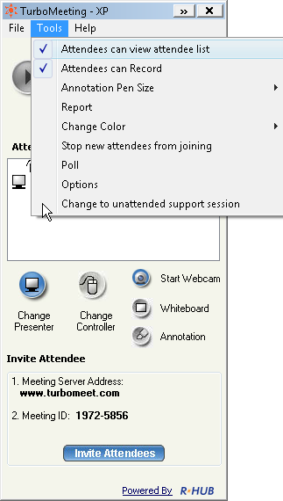
Supporter changes to unattended support session

The supporter must enter a Computer Name for the supportee and a Meeting Password:

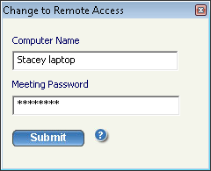
Supporter enters supportee’s computer name and a meeting password
The supportee must accept that the supporter can provide unattended support:

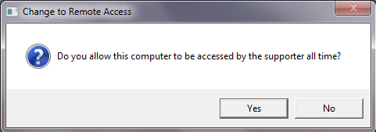
Supportee should accept that the supporter can provide unattended support

This meeting has now become a Remote Access meeting. From now on, the supporter will be able double click the meeting ID to access this meeting from their Active meeting list:

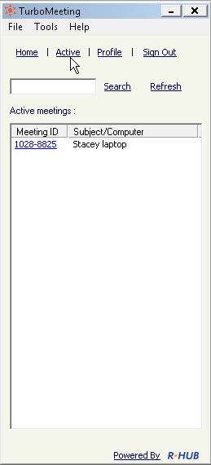
Supporter will always see this Remote Access meeting in their Active list

Scheduling Meetings
There might be instances when you have planned a meeting earlier and want to inform the invitees in advance. In such cases, you can schedule the meeting using the Schedule Meeting option.

6.1 Scheduling a Meeting
To schedule a meeting:
- Log into GoSupportNow.
- Click Schedule a meeting.
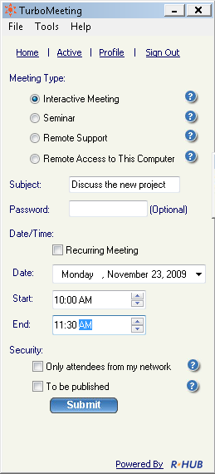
Scheduling meetings
- Select the Meeting Type.
- Mention the Subject of the meeting.
- Enter the password, which is optional for all meeting types but Remote Access to this Computer.
- Select the Date.
- Select the Start and End time.
- Select Recurring Meeting to schedule a recurring meeting. If this option is selected, the Date and Time options are disabled.
- Click Submit.
When you login to GoSupportNow next time, the scheduled meetings and the details are displayed.

6.2 Editing a Scheduled Meeting
To edit a scheduled meeting:
- Click the Edit link of the respective meeting.
- Make the necessary modifications.
- Click Submit.

6.3 Starting a Schedule Meeting
To start a scheduled meeting, click the Start link for the respective meeting.

6.4 Deleting a Schedule Meeting
To delete a scheduled meeting, click the Delete link of the respective meeting. After a confirmation dialog, a message box says that the schedule meeting has been deleted.
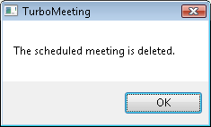

Alert after the meeting is deleted

Managing Profile
Follow these steps to manage your profile:
- Log into GoSupportNow.
- Click Profile.
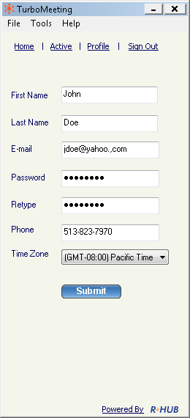
Managing profile
- Edit your First Name, Last Name, and E-Mail.
- Provide a Password and Retype your password to confirm it.
- Specify your contact number.
- Choose the relevant time zone.
- Click Submit.

Support Contact

RHUB Communications, Inc.
4340 Stevens Creek Blvd.
Suite 282
San Jose, CA 95129
Tel: 408-642-5221
Fax: 408-516-9612
support@rhubcom.com
http://www.rhubcom.com

